[WOBI-14] Completing automatic words in the city name text box is not working for the letters ר ח ד Created: 18/Feb/24 Updated: 29/Feb/24
Status: | To Do
Project: | Wobi

Type: | Bug | Priority: | Medium
Reporter: | Tomer Darmon | Assignee: | Tomer Darmon
Environment: | Browser :  Chrome Version 121.0.6167.140  Firefox Version 122.0.1  Microsoft Edge Version 121.0.2277.106

Attachments: | 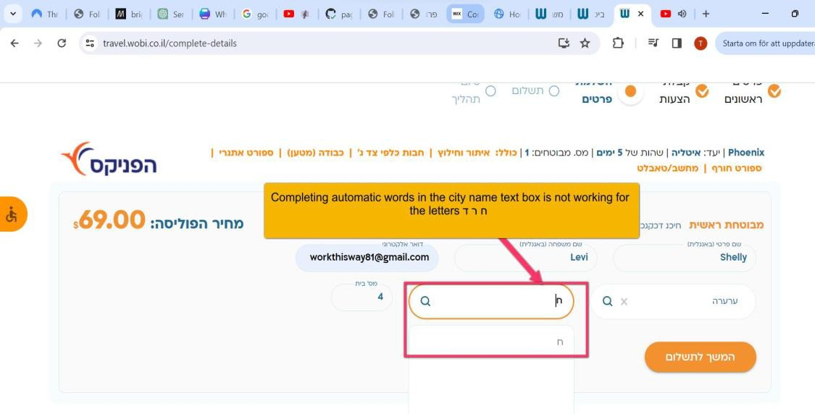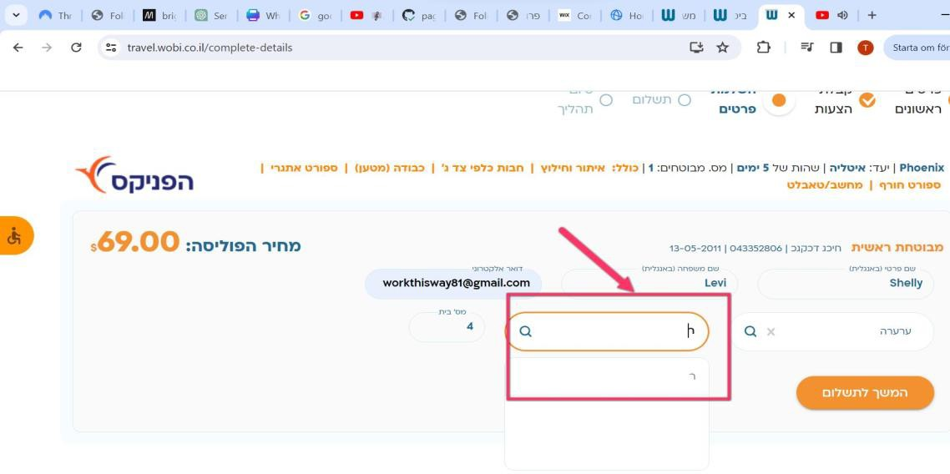
Severity: | S5- Low

30

Description
Steps to Reproduce :
1. Enter URL https://www.wobi.co.il/
ביטוח נסיעות לחו”ל tab the Press 2.
- Press on the next tab לחסוך טוסו
- On the new page choose the options: dates , destination and press to continue
- Fill in your personal details like birth date, surname and family name, I.D. and gender then press continue
- Fill in the options between לא/כן regarding the health situation questions and then press to continue
- Choose from the options in the new page if you would like to add some other insurance and approve before you press continue to the next new page
- You will have a new window that will offer to add insurance for your suitcase, you can choose yes or not
- Choose your insurance suggestion that looks to you the most attractive
- Then fill in Your full name in English and the other details.
- After choosing a city, you will choose a street and notice that there are some letters like ד ,ר ,ח, which are not having the completing word like other letters have
Actual Result: The letters ר ד ח are not working like the other letters when you type them and they are completing the whole street name immediately.
Expected Result : The letters חדר will show options of streets that start with those letters

31

